Sales Performance Analysis
- Introduction
Sales data analysis plays an important role in understanding business performance and customer purchasing behavior. In this project, sales transaction data was analyzed using Microsoft Power BI to identify patterns, trends, and key performance indicators. The main goal of this project is to transform raw sales data into meaningful insights that can help businesses make informed decisions.

2. Objective of the Project
• To analyze sales transaction data.
• To identify revenue trends over time.
• To determine top-selling products.
• To analyze regional sales performance.
• To build an interactive dashboard for visualization.

3. Dataset Description
The dataset used in this project contains sales transaction information including invoice numbers, product descriptions, quantities sold, unit prices, countries, and invoice dates.
Key attributes in the dataset include:
• Invoice Number
• Product Description
• Quantity Sold
• Unit Price
• Country
• Invoice Date
• Customer ID

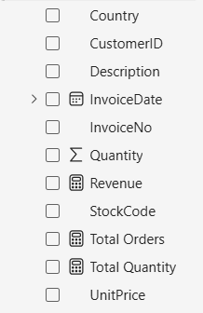

4. Data Preparation
Before performing the analysis, the dataset was cleaned and organized to ensure accurate results. Data preparation steps included checking for missing values, verifying column data types, and organizing the dataset for analysis.
These steps helped ensure the data was consistent and suitable for visualization and analysis.

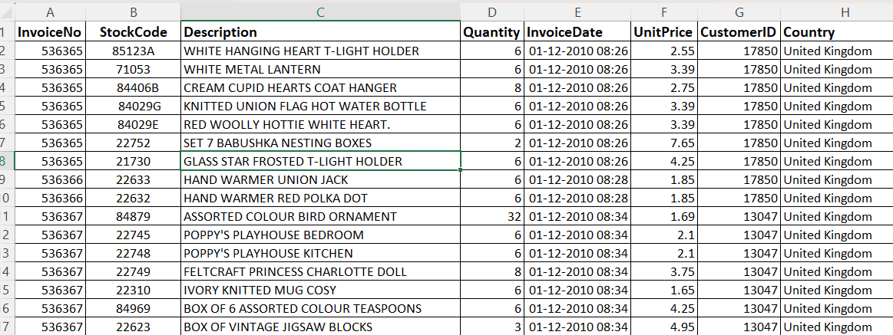
5. Data Analysis
Revenue was calculated using the formula:
Revenue = Quantity × Unit Price
This calculation helped determine the total revenue generated from sales transactions. Additional measures such as total quantity sold and total number of orders were also created to analyze overall business performance.

6. Dashboard Development
An interactive dashboard was created using Power BI to visualize important business insights. The dashboard includes key performance indicators such as total revenue, total quantity sold, and total orders. It also includes charts to display revenue trends, top-selling products, and regional sales performance.

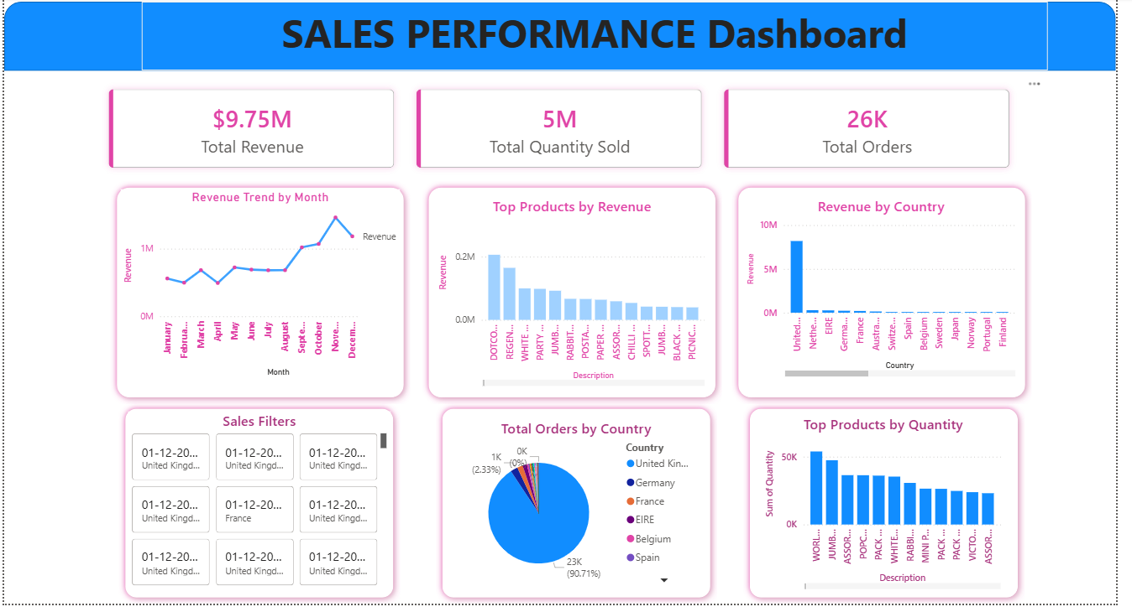
7. Key Insights
The analysis revealed several important insights:
• Revenue trends indicate variations in sales performance over time.
• Certain products contribute significantly to total sales revenue.
• Some countries generate higher revenue compared to others.
• A small group of products drives a large portion of sales.

8. Conclusion
The Sales Performance Analysis project demonstrates how business intelligence tools can be used to analyze large datasets and extract valuable insights. By using Power BI, sales data was transformed into an interactive dashboard that clearly visualizes business performance. This analysis helps organizations understand sales patterns, identify profitable products, and make better strategic decisions.

The project also helped develop practical skills in data analysis, visualization, and business intelligence tools.

